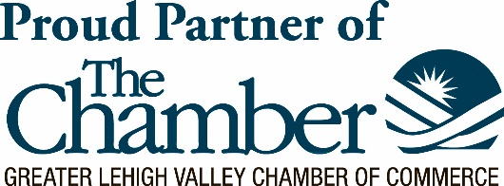
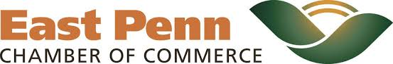
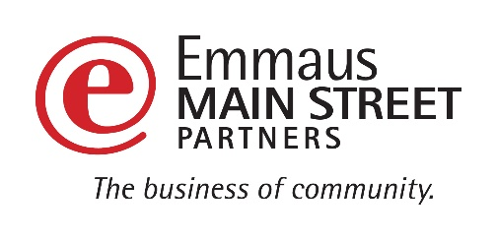

Eat Up East Penn!
2024 Annual East Penn Area Restaurant Week
Sun. February 25th – Sat. March 2nd

SPONSORSHIP OPPORTUNITIES
The East Penn Chamber of Commerce and Emmaus Main Street Partners would like to cordially invite you to participate in and support our annual East Penn Area Restaurant Week, taking place from February 26th through March 4th, 2023.

Each year the Chamber of Commerce hosts various Restaurant Weeks throughout the Greater Lehigh Valley. We are looking for the support of our business community to rally together to support businesses in our area through East Penn Restaurant Week. This event brings awareness, exposure, foot traffic, and energy to our local restaurants while we advertise on their behalf, driving new and returning business back through their doors.

Be a part of this year’s support and success with this opportunity to put your name in front of thousands of people!
Advertising and Promotional Avenues for the event have included / may include the following:
- East Penn Press advertisement
- Gift card giveaway on WAEB AM 790 where host will advertise the event
- Connecting with iHeart radio to advertise on air and giveaway gift cards where hosts will mention event
- Facebook event pages and posts on EMSP, EPCC, and GLVCC pages
- Ad in Connections magazine – the Chamber’s monthly publication
- Eblasts to the Affiliated Chambers
- Events poster hanging in participating restaurants, sponsors businesses, and high pedestrian areas
- Media mentions online in up to 18 additional PA or Lehigh Valley community event calendars
- Banner hung across Main St in Emmaus by Superior Diner where 19,000 cars pass daily
- Press Release sent to over 200 media contacts across the greater Lehigh Valley
- WFMZ coverage with participating chefs on air

SPONSORSHIP LEVELS ARE AS FOLLOWS:
(Commit by January 15, 2024 to get the best exposure on marketing materials) **Checks should be made Payable to “GLVCC”

- PRESENTING SPONSORSHIP $2500 (ONLY ONE! Chamber Member)
  - Your logo and title as a PRESENTING SPONSOR on all Restaurant Week posters / fliers, online and print advertisements
  - Prominent logo placement on East Penn Restaurant Week webpage.
  - Your company logo on all Restaurant locations’ Special Restaurant Week Menus
  - Recognition as the Presenting Sponsor in press release and web listings about Restaurant Week. (web listings may vary depending on site regulations)
  - Recognition as Presenting Sponsor on EPCC, EMSP and GLVCC social media pages. Two individual thank you posts and “tags”/”mentions” throughout course of promoting event.
  - Opportunity to create a 30-second video promoting the event and your business’s support and sponsorship
  - Logo on recap reel on Affiliated Chambers Instagram & TikTok
  - Sponsor shout-outs on Facebook Page and in Facebook Event
  - Complimentary E-blast to affiliated Chamber list of your choice ($200 value)

- GOLD SPONSORSHIP $1,200 (Chamber Member) $2,200 (Future Member)
  - Your logo on Restaurant Week posters, flyers, print advertisements, etc.
  - Your logo placement on webpage with a clickable link to your website as a Gold Sponsor
  - Recognition as a Gold Sponsor in press release(s) about Restaurant Week
  - Recognition as a Gold Sponsor on EPCC, EMSP and GLVCC social media pages with tags, where applicable, to your business page (LinkedIn, Facebook, Instagram, etc.)
  - Opportunity to create a 30-second video promoting the event and your business’s support and sponsorship
  - Logo on recap reel on Affiliated Chambers Instagram & TikTok
  - Sponsor shout-outs on Facebook Page and in Facebook Event
  - 1 member spotlight in East Penn e-newsletter leading up to Restaurant Week event ($50 value)

- SILVER SPONSORSHIP $900 (Chamber Member) $1,800 (Future Member)
  - Your logo on Restaurant Week posters, flyers, print advertisements, etc.
  - Your logo placement on webpage with a clickable link to your website as a Silver Sponsor
  - Recognition as a Silver Sponsor in press release(s) about Restaurant Week
  - Recognition as a Silver Sponsor on EPCC, EMSP and GLVCC social media pages with tags, where applicable, to your business page (LinkedIn, Facebook, Instagram, etc.)
  - Opportunity to create a 30-second video promoting the event and your business’s support and sponsorship
  - Logo on recap reel on Affiliated Chambers Instagram & TikTok
  - Sponsor shout-outs on Facebook Page and in Facebook Event

- BRONZE SPONSORSHIP $600 (Chamber Member) $1,200 (Future Member)
  - Your logo on Restaurant Week posters, flyers, print advertisements, etc.
  - Your logo placement on webpage with a clickable link to your website as a Bronze Sponsor
  - Recognition as a Bronze Sponsor in press release(s) about Restaurant Week
  - Recognition as a Bronze Sponsor on EPCC, EMSP and GLVCC social media pages with tags, where applicable, to your business page (LinkedIn, Facebook, Instagram, etc.)
  - Logo on recap reel on Affiliated Chambers Instagram & TikTok
  - Sponsor shout-outs on Facebook Page and in Facebook Event

- SUPPORTING SPONSORSHIP $300 (Chamber Member) $600 (Future Member)
  - Your logo placement on webpage with a clickable link to your website
  - Recognition as a Sponsor in press release(s) about Restaurant Week
  - Sponsor shout-outs on Facebook Page and in Facebook Event

