Lower Macungie “Our Town Heroes” Banner Program
Round 1
Mission
East Penn Chamber of Commerce and Lower Macungie Township have come together to recognize & show appreciation for veterans, military personnel & families with the “Our Town Heroes” Banner Program.

Participation Qualification
To qualify, the honoree must either be active duty, retired, honorably discharged, or a deceased member of United Armed Forces: Army, Marine Corps, Air Force, Navy, or Coast Guard. Individuals applying for the banner should be of good reputation and must be in good standing with Lower Macungie Township and may be subject to a background check.

Application Requirements
Each banner requires the form/application to be completed, an original, physical photograph of the hero in uniform, and payment. First come, first served. You can pay by cash, check, or card. Additional payment details are available on the other side of this document.

Banner Design, Time Frame & Location
Banners are 24” x 48”, double-sided, vinyl material, and include service person’s name, branch of service, years of service, and photograph. Banners will be hung for two consecutive years in designated high traffic locations throughout Lower Macungie. The specific banner locations will be selected at random and specific display locations cannot be requested. After banners are hung for the second year, applicants may decide whether to keep the banner and/or continue with the program or not.

Banner Photograph
Please submit an original, physical photograph of the hero in uniform. The photo will be scanned to put on the banner so understand that it can look only as good as the original picture provided. Once photo has been scanned into our system, we will contact you to retrieve your original photo..

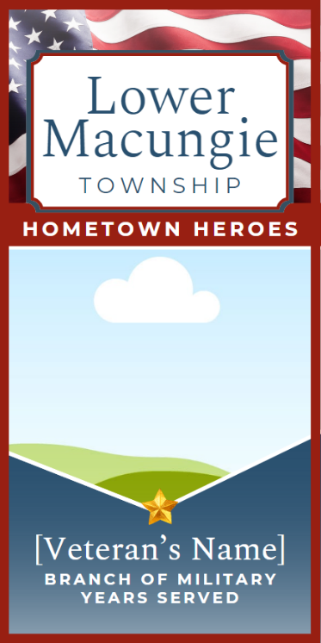
Payment Banner Image

Banners are $150.
Payment can be made to ‘GLVCC.’
They can be mailed to

GLVCC
191 Main St Suite 205
Emmaus, PA 18049

Lower Macungie “Our Town Heroes”
Round 1

HONOREE INFORMATION

Veteran’s Name: _________________________________________________________________________________

Years of Service: _______________________ - _________________________

Circle the Branch of Military:

Army Marine Corps Air Force Navy Coast Guard

APPLICANT’S INFORMATION

Name: ________________________________________________________________________________________

Phone Number: ______________________________ Address: ____________________________________

Email: _______________________________________________________________________________________

Photo Release:
I herby grant the East Penn Chamber of Commerce permission to use the attached photo (which includes a likeness of me, my relative, or person being sponsored) in the Our Town Heroes Banner Program without payment of other considerations.

Signature Printed Name Date

Payment Information
(please circle)

Cash Check Credit Card

Checks can be made out to “GLVCC” and with all necessary materials be mailed or delivered to Emmaus Main Street Partners 191 Main St Suite 205 Emmaus PA 18049.

If you would like to pay with credit card, please call (484) 828 - 9777 with the card information or be prepared to provide it when you drop off the application in person.

Contact Information
For questions, contact Hayden Rinde, East Penn Chamber Liaison, at (484) 828-9777 or HaydenR@LehighValleyChamber.org

Applications will be accepted on a first come, first served basis & must have all necessary materials.

